SDEV400 6381: Secure Programming in the Cloud

Homework 1: S3 Bucket Application

Mark Kardash

Professor Nathan Braun

University of Maryland Global Campus

23 January 2024

The results from my Homework 1 are as follows:

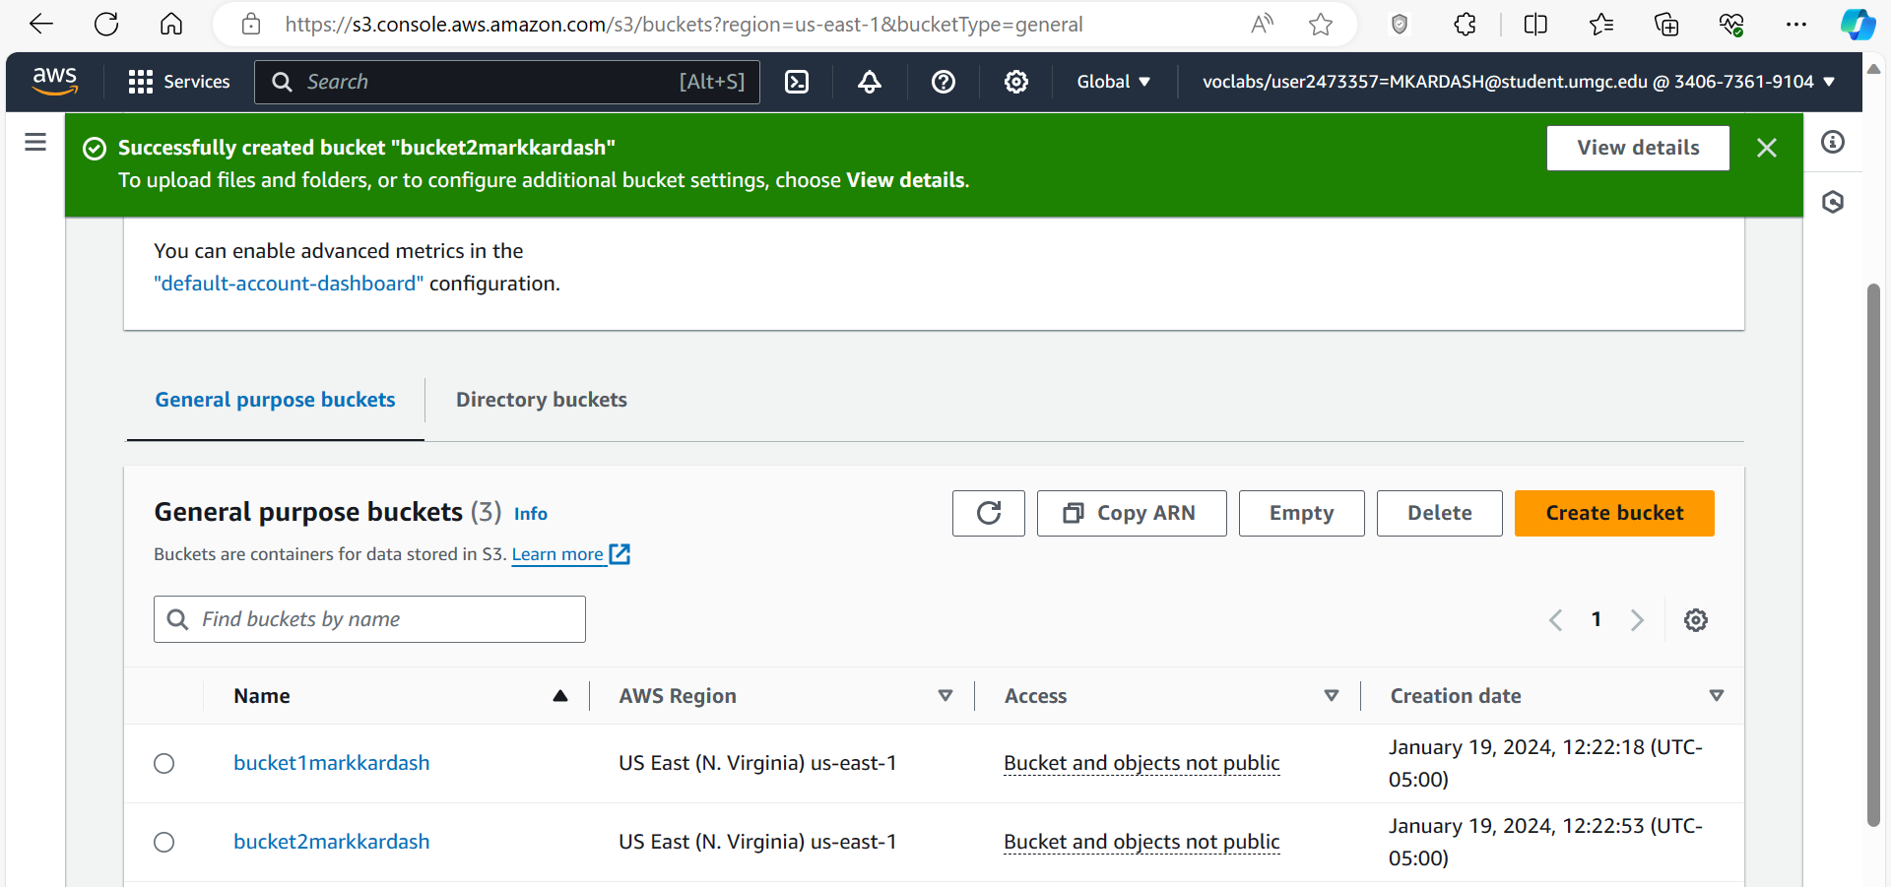

**Figure 1:** Successful bucket creation.

In the figure above, the two requested buckets, named “bucket1markkardash” and “bucket2markkardash” have been successfully created.

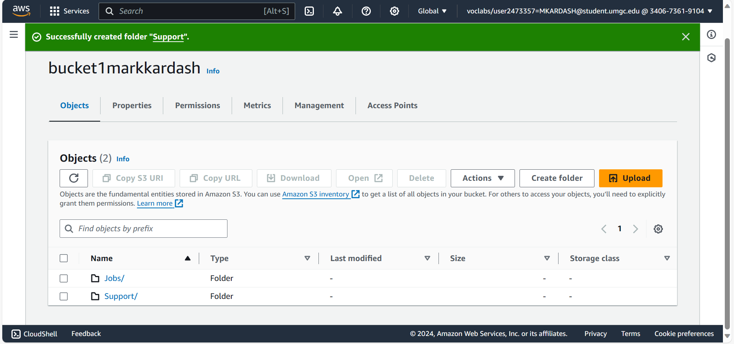

Figure 2: Successful Creation of Folders Inside First Bucket.

Above, one can see that the requested “Jobs” and “Support” folders have been successfully created within “bucket1markkardash”.

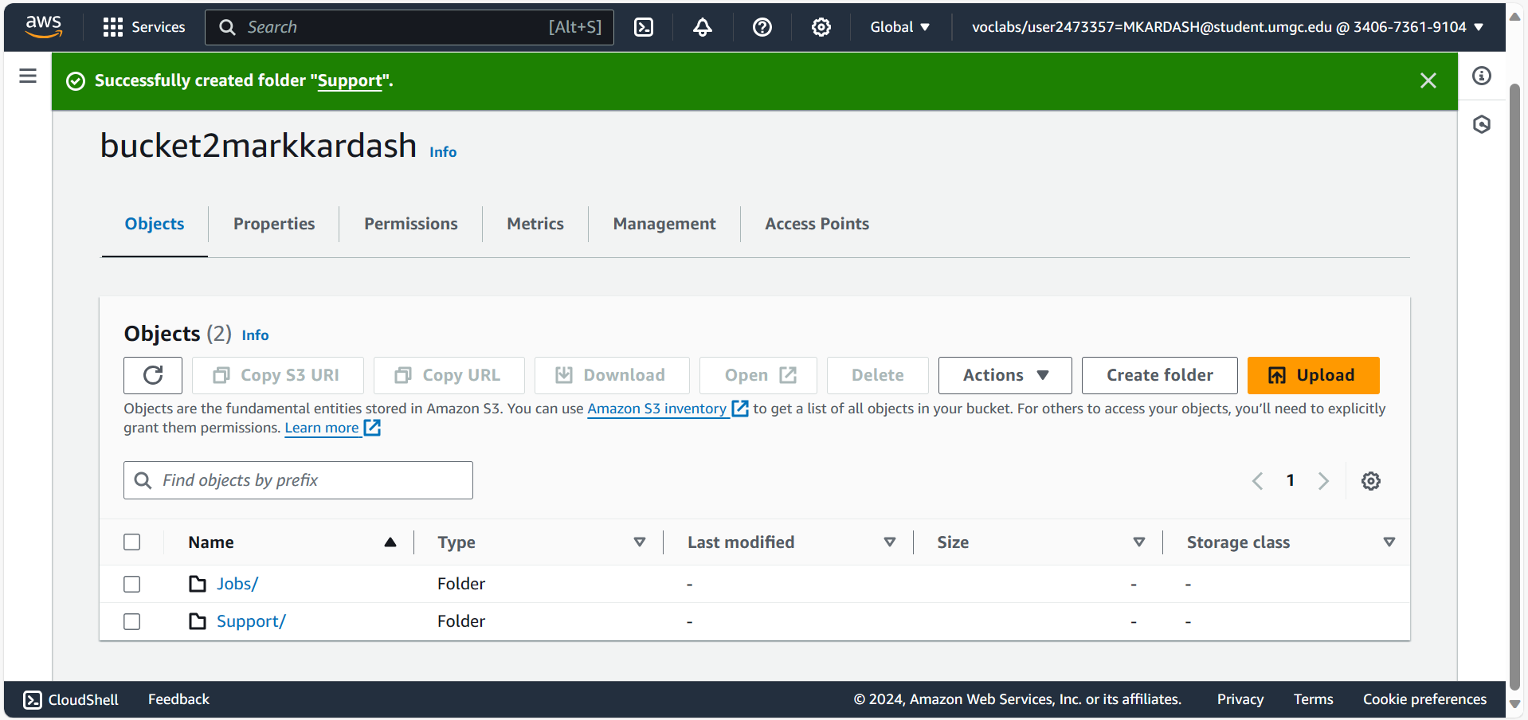

Figure 3: Successful Creation of Folder Inside Second Bucket

The image above shows the successful execution of the previous step for the second folder.

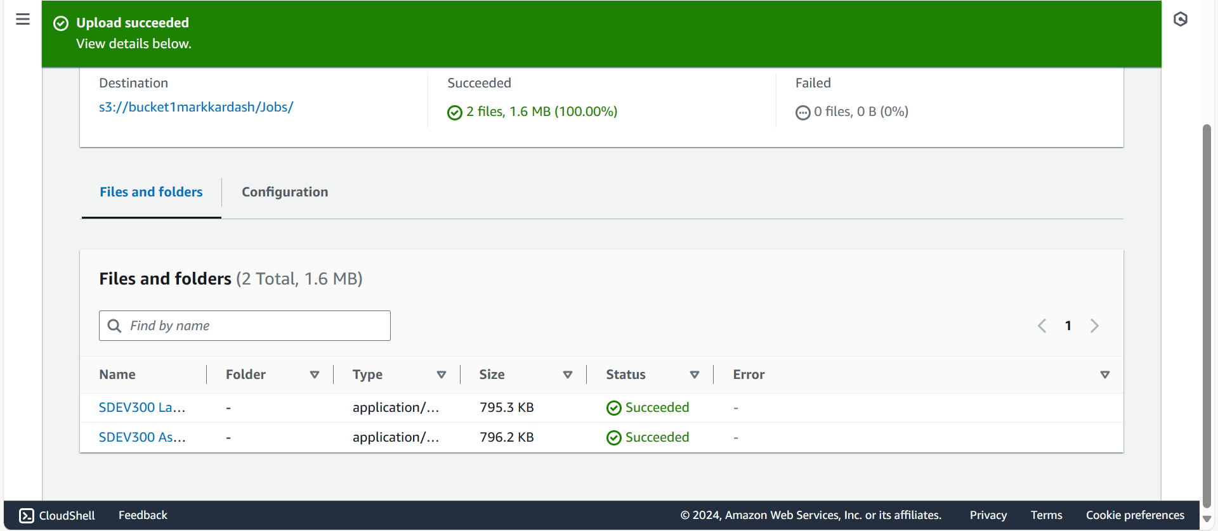

Figure 4: Uploading files to first folder of first bucket

Here, two documents from a previous course, SDEV300, are uploaded to the Jobs folder of “bucket1markkardash”.

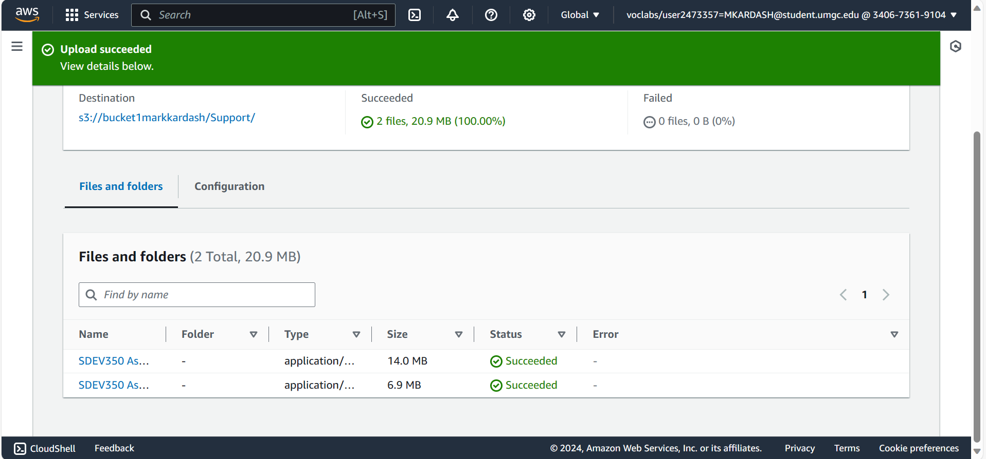

Figure 5: Uploading files to second folder of first bucket.

Now, we upload two files from my SDEV350 course to the Support folder of bucket1markkardash.

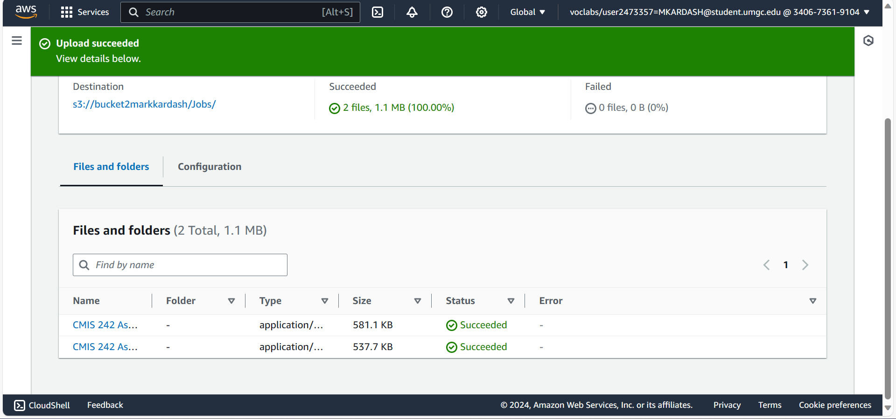

Figure 6: Uploading files to first folder of second bucket

Above, two files from the CMIS242 course are successfully uploaded to the Jobs folder of “bucket2markkardash”.

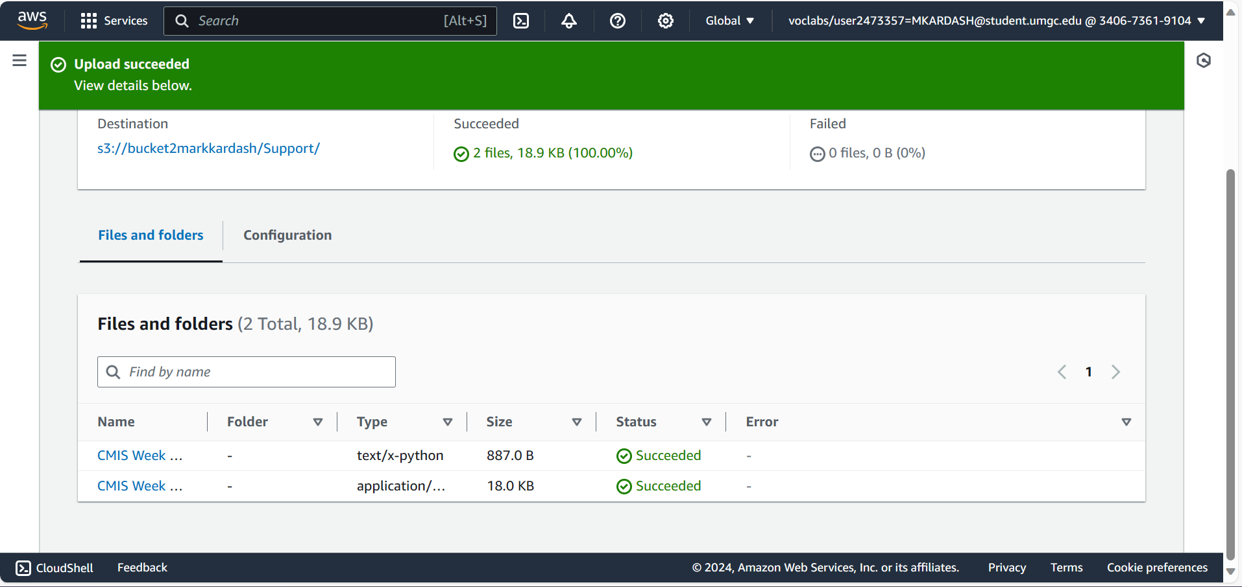Figure 7: Uploading files to second folder of second bucket.

Finally, several files from a CMIS course are uploaded into Support, in “bucket2markkardash”, thus completing this stage of the assignment.

The test cases for my Bucket application are displayed below:

|  |  |  |  |  |
| --- | --- | --- | --- | --- |
| Test Case #: | Input: | Expected Result: | Actual Result: | Pass/Fail?: |
| 1 | 1 | Bucket “markkardash-409175” created successfully. Message “Bucket markkardash-409175 created successfully” displayed. Main menu displayed. | Bucket “markkardash-409175” created successfully. Message “Bucket markkardash-409175 created successfully” displayed. Main menu displayed. | Pass |
| 2 | 2 | Object “SDEV400-HW1-Sample-file.py” successfully placed in “markkardash-409175” bucket.  “Object SDEV400-HW1-Sample-file.txt has been successfully added to bucket markkardash-409175” message displayed. | Object “SDEV400-HW1-Sample-file.py” successfully placed in “markkardash-409175” bucket.  “Object SDEV400-HW1-Sample-file.txt has been successfully added to bucket markkardash-409175” message displayed. | Pass |
| 3 | 4 | Object “SDEV400-HW1-Sample_file.py” successfully copied from bucket “markkardash-409175” to bucket “bucket1markkardash”. Message displayed. | Object “SDEV400-HW1-Sample_file.py” successfully copied from bucket “markkardash-409175” to bucket “bucket1markkardash”. Message displayed. | Pass |
| 4 | 5 | Object “SDEV400HW1SampleFile.txt” successfully downloaded and saved from bucket as SDEV400HW1SampleFile-download.txt”. Corresponding message displayed. | Object “SDEV400HW1SampleFile.txt” successfully downloaded and saved from bucket as SDEV400HW1SampleFile-download.txt”. Corresponding message displayed. | Pass |
| 5 | 3 | Object “SDEV400-HW1-Sample-file.py” successfully deleted from bucket “markkardash-409175”. “File SDEV400-HW1-Sample-file.txt has been successfully deleted from bucket markkardash-409175” message displayed. |  |  |
| 6 | 7 | “Sorry! You selected an invalid choice!” message displayed. | “Sorry! You selected an invalid choice!” message displayed. | Pass |
| 7 | 6 | “Thank you for using our application!” message displayed. Datetime displayed. | “Thank you for using our application!” message displayed. Datetime displayed. | Pass |

Test Case Screenshots:

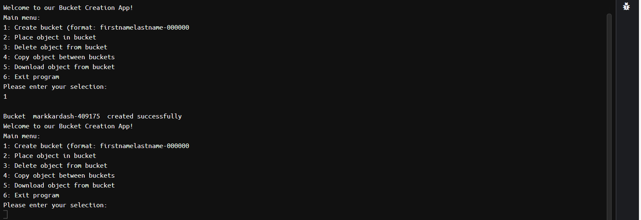

Figure 1: Test Case 1: Creating the Bucket

In the above screenshot, the first test is shown to have been passed successfully. The app informs us that the new bucket has been created, and displays the menu once more.

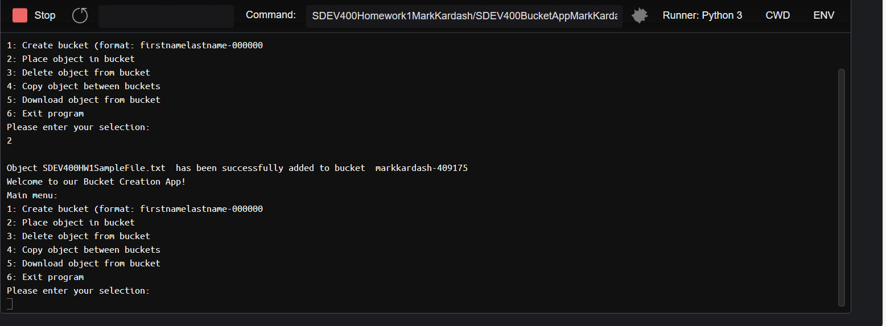

Figure 2: Uploading file to bucket

The above figure shows the successful addition of the file SDEV400HW1SampleFile.txt to the markkardash-409175 bucket.

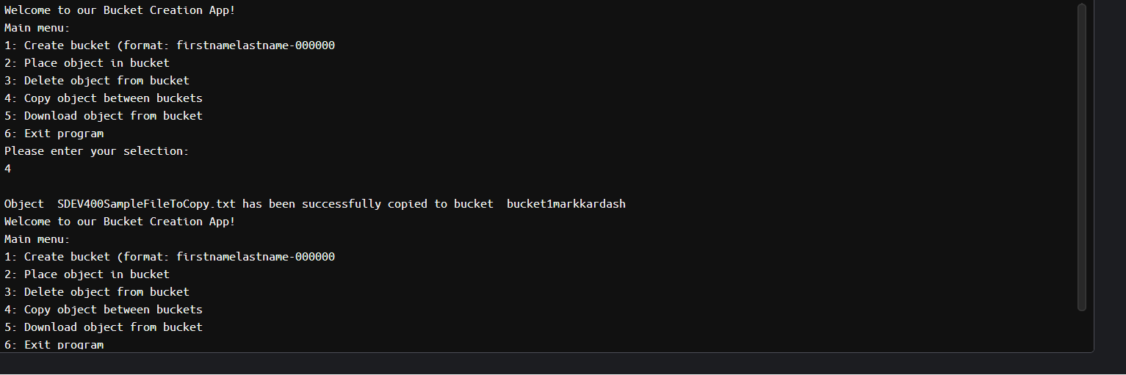

Figure 3a: Copying file between buckets

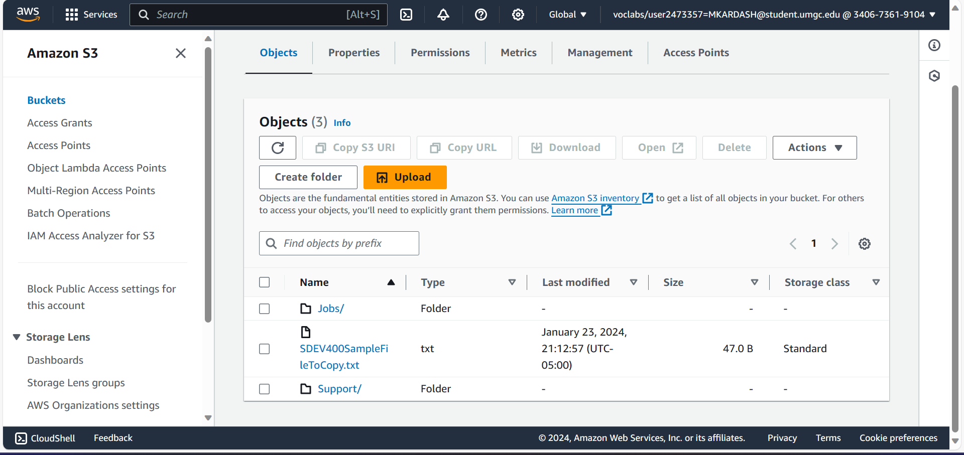

Figure 3b: Confirmation of successful copying of file between buckets

Figures 3a and 3b demonstrate that the file SDEV400SampleFileToCopy.txt was successfully copied from markkardash-409175 to bucket1markkardash, with the latter image confirming it by showing the file inside the second bucket.

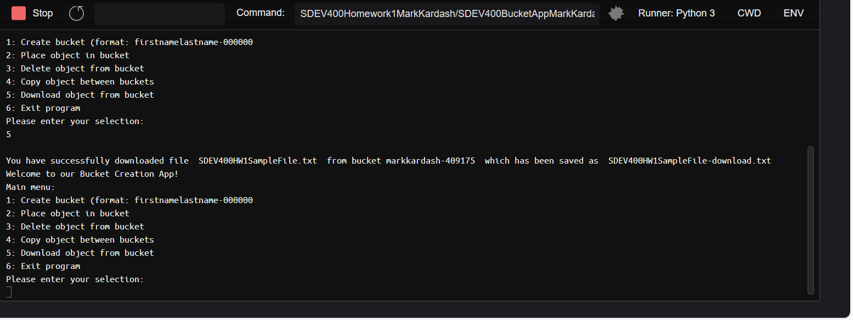

Figure 4a: Downloading object from bucket

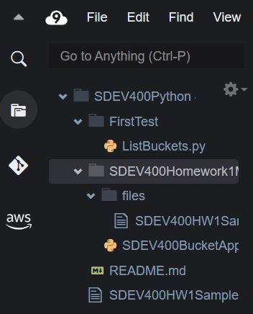

Figure 4b: Confirmation of successful file download

The two above figures demonstrate that the download of the file, and its renaming into “SDEV400HW1SampleFile-download.txt” has been completed successfully (The last file on the bottom of Figure 4a being the download).

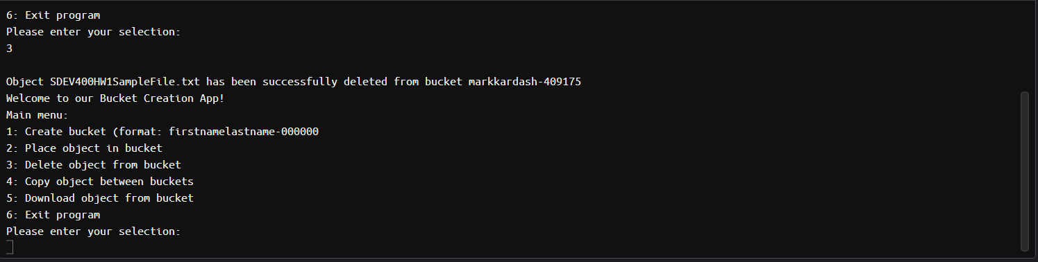

Figure 5a: Successful deletion of file from bucket

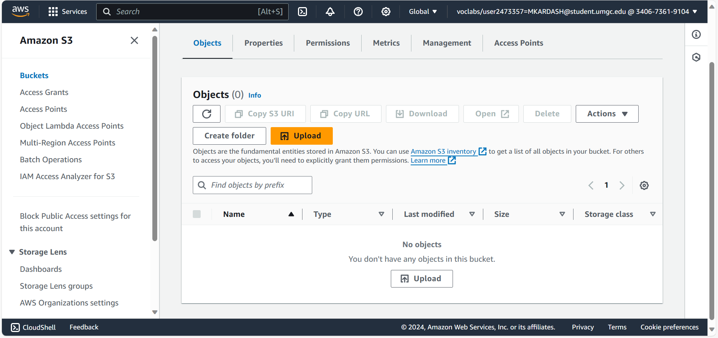

Figure 5b: Proof of successful file deletion

Figures 5a and 5b demonstrate the successful deletion of the file SDEV400HW1SampleFile.txt from the “markkardash-409175” bucket. As can be seen in the second figure, the bucket no longer has any files.

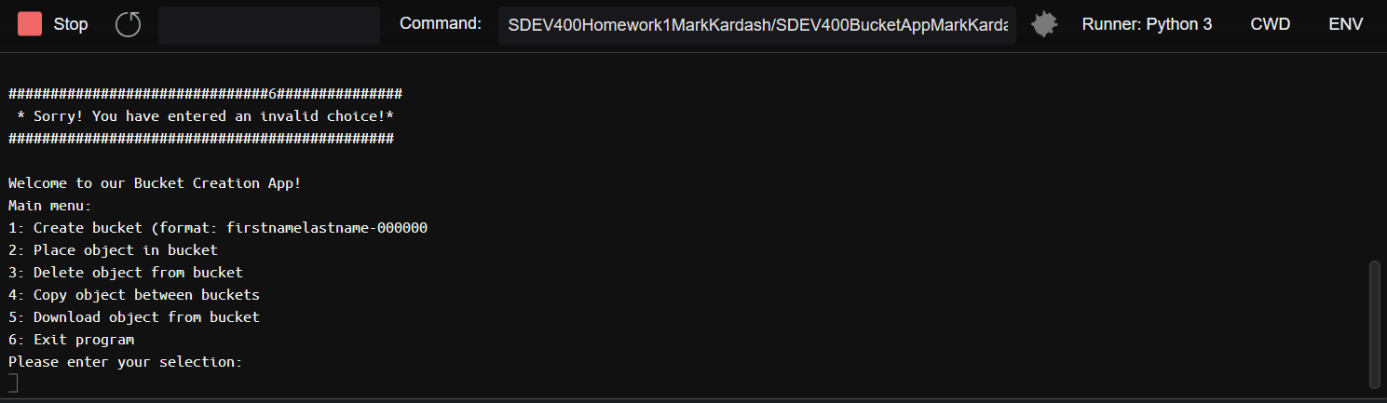

Figure 6: Invalid Selection message

Figure 6 shows the result of an invalid input, which is a message informing the user that their choice was invalid.

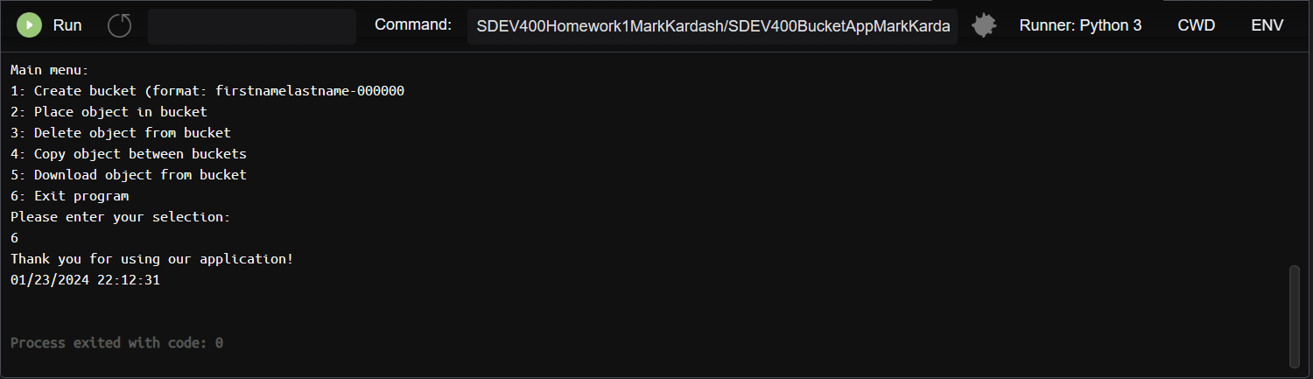

Figure 7: Exiting the application

Above, the user is shown to have successfully exited the application, with a “Thank you” message, and the timestamp, displayed on the screen.

Summary:

After a bit of struggle, I finally managed to get all selections to produce the correct result. The application passed the test cases with flying colors, thus completing the assignment.

References:

Cloud9 | us-east-1 (amazon.c https://us-east-1.console.aws.amazon.com/cloud9/ide/6c9c3c00761b42adbaab6163190bcc91?region=us-east-1 om)